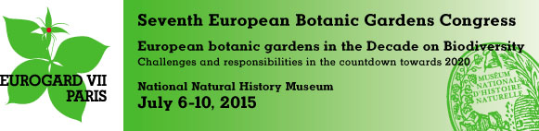
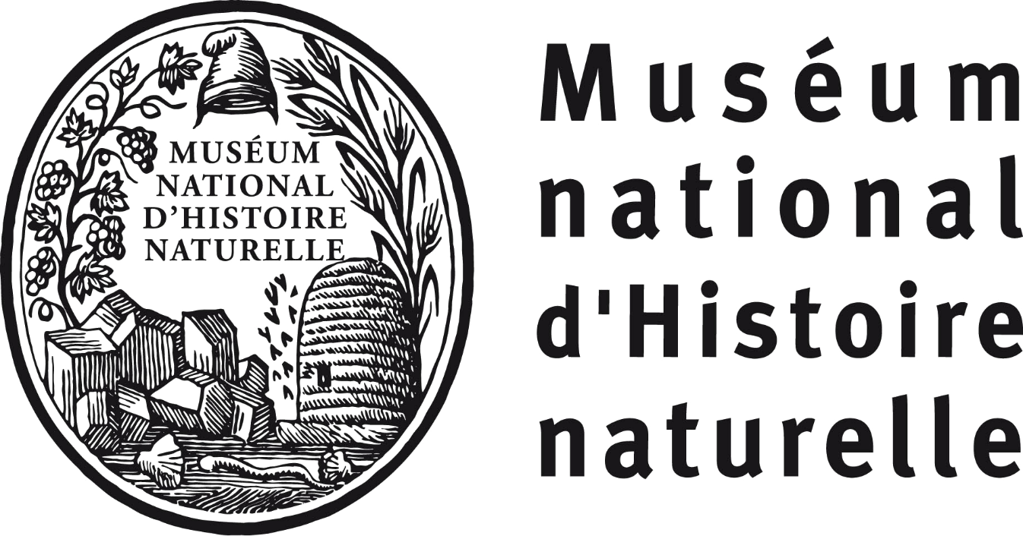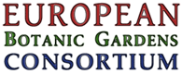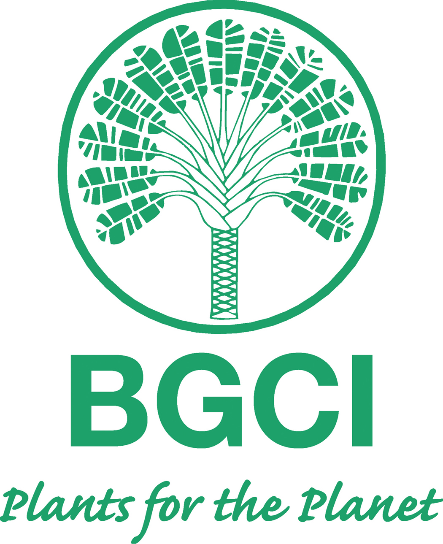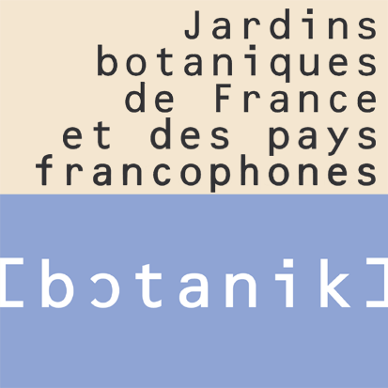

The European Botanic Gardens Congress, EuroGard VII, will be held in Paris from July 6-10, 2015 at the National Natural History Museum. It is organised in partnership with the European Botanic Gardens Consortium (EBGC), Botanic Gardens Conservation international (BGCI), and Jardins botaniques de France et des pays francophones (JBF).
EuroGard VII will bring together representatives from botanic gardens across Europe. The scientific programme will be focused around the new version of the European Botanic Gardens Action Plan, which will be officially launched during the Conference. The conference will address the issues and challenges facing botanic gardens in the Decade on Biodiversity and will consider opportunities and prospects for the community of botanic gardens.
The program will be structured around the following themes:
- Policies and guidelines
- Science
- Heritage, culture and tourism
- Conservation
- Education
- Climate change
- Networking, cooperation and capacity building

2015 is a highly symbolic year for botanic gardens as they develop their responses to:
- The Mid-term review of the Global Strategy for Plant Conservation and of the CBD’s Strategic Plan for Biodiversity 2011-2020
- The entry into force of the Nagoya Protocol and the Access and Benefit Sharing (ABS) policy of the European Union. The congress will provide an important opportunity to discuss the implementation of ABS in botanic gardens.

The congress will also address capacity building to support the Global Strategy for Plant Conservation with a focus on relevant collaborations between European botanic gardens and partners in developing countries.
The event will be held at the National Museum of Natural History, an institution recognized for the excellence of its expertise, and its program of conservation, research and dissemination of scientific knowledge. Extensive renovations projects have been conducted for its botanic gardens, zoos and the national herbarium between 2010 and 2015.
Official Language: English (interpretation will be provided for the plenary sessions in French and English)
The conference website is now available at: http://eurogard2015.sciencesconf.org/
The registration of participants is open at: http://eurogardvii.mycongressonline.net/
Pre and Post tours can be booked at: http://www.boxwoodtours.eu/

